Application form

First name and family name: ...........................................................................................................

Academic position and academic degree: .....................................................................

Organization: ......................................................................................................................................................................................................................

Postal address, telephone for contacts, e-mail: .................................................................

Participation:
- Oral presentation
Title of oral presentation:
……………………………………………………………………...
......................................................................................................................................................................................................................
Authors: ……………………………………………………………………...……………………………………………………………………...

- Poster presentation
Title of poster presentation:
……………………………………………………………………..
..........................................................................................................
……………………………………………………………………...
Authors: ……………………………………………………………………...………………………………………………………………….......

Please send the filled in application forms before April 30, 2019 to Prof. Reni Kalfin
E-mail: reni_kalfin@abv.bg

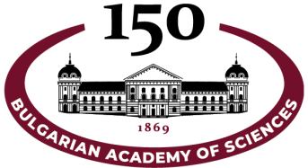

SCIENTIFIC CONFERENCE WITH INTERNATIONAL PARTICIPATION
“NEUROSCIENCE, BIOINFORMATICS, MICROBIOME AND BEYOND”

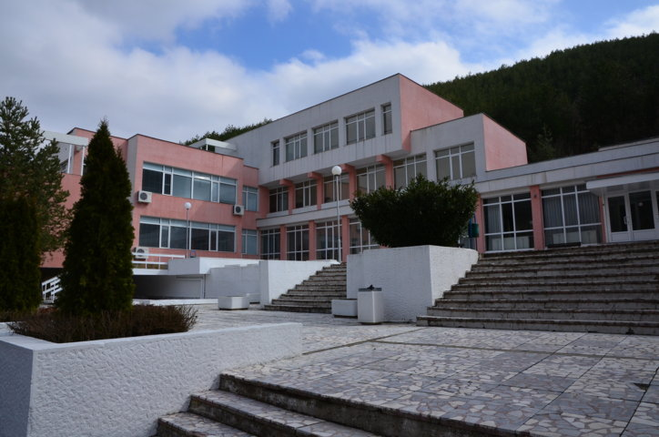

17-19 September 2019, Bachinovo, Bulgaria
Dedicated to the 150th Anniversary of the Bulgarian Academy of Sciences

ORGANIZING COMMITTEE
Chairperson: Prof. Reni Kalfin
Members: Assoc. Prof. Katerina Stambolieva
Assoc. Prof. Dimitrinka Atanasova
Assoc. Prof. Ivanka Stankova
Prof. Stefan Panaiotov
Prof. Anna Tolekova
Prof. Elena Dzhambazova
Assist. Prof. Boris Kadinov
Assist. Plamenka Nanova
Assist. Prof. Radoslav Chayrov
Secretary: Assist. Prof. Polina Mateeva
PROGRAM COMMITTEE
Prof. Juliana Yordanova
Assoc. Prof. Mariya Antonova
Assoc. Prof. Lyubka Tancheva

The Institute of Neurobiology will undertake the expenses for the Conference attendance.

No registration fee.

English is the official language of the Conference.

It may be of interest for biologists, pharmacologists, physicians, chemists, psychologists, students as well as for everybody who is interested in neurobiology and medicine.

All participants in the Conference will be granted a Certificate for participation.

Please send the filled in application forms before April 30, 2019 to Prof. Reni Kalfin
E-mail: reni_kalfin@abv.bg

